PO NO : - NVA – 721 Annexure – A For Terms And Conditions
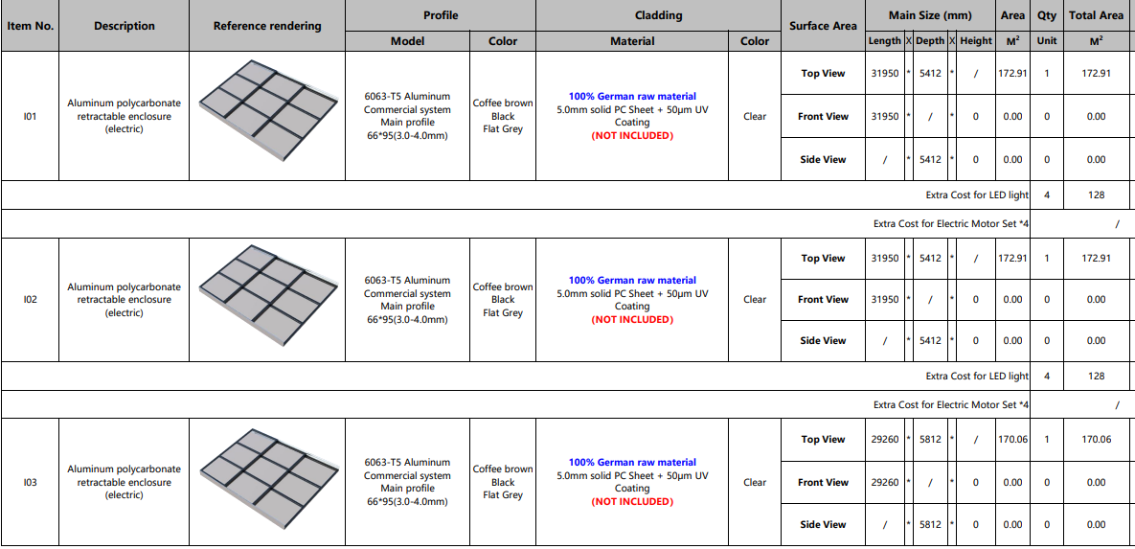
Technical Conditions:
- Need to consider and supply all material require for installation except polycarbonate sheet.
- All Drawings should be submitted. (Civil Drawing, MS structure drawing, Water drainage drawing, Electrical drawing, etc).
- All manual should be submitted. (Installation manual, Maintenance manual, Assembly manual, Electrical manual, daily check list of roof).
- Polycarbonate fitting arrangement and fitting process should be define with video and manual.
- EPDM rubber TC and fitting arrangement mention.( Chinese Top brand ''Haida'' EPDM rubber seal)
- All material TC compulsory, Powder Certificate and Powder coating test report must be submitted with stamp and seal.(AL profile 6063- T5).
- Motor warranty certificate require. Motor make NICE.
- All necessary spare part drawing and list with price require.
- All Hardware should be SS-304.
- Internal quality and inspection report require with Photos and Videos.
- Assembly and Trail of Roof video require compulsory.
- All manual communication Language should be in English.
Warranty Conditions:
- AL profile 6063- T5, 30 years warranty
- EPDM rubber Chinese Top brand ''Haida'' EPDM rubber seal with 10 years warranty
- Motor, Remote, Receiver Nice make (RUN 2500) warranty 2 years.
- Bus bar, current collector etc accessories warranty certificate with detailed specification require.
Delivery Conditions:
- All material should be packing as per sea shipment norms. Polywood case+plastic belts+protective film+PE foam
- Delivery- 25-30 days.

